

|  |
| --- |
|  |
| LUXURY STAY Hospitality |
| DEVELOPER GUIDE |

SIR ALI IMRAN HUSSAIN | MISS SANA YOUSUF

|  |  |  |  |  |  |  |  |  |  |  |
| --- | --- | --- | --- | --- | --- | --- | --- | --- | --- | --- |
| |  |  | | --- | --- | | Enrollment ID | Student Name | | Student1346661 | YAHYA AHMED MUGHAL | | Student1365428 | AZHAR SHAH | | Student1370719 | CHRIS RIAZ | | Student1365416 | ABDUL MUGHNI SIDDIQUI | |
| SIR ALI IMRAN HUSSAIN | MISS SANA YOUSUF | |



|  |  |
| --- | --- |
|  | Decorative |
| TABLE OF CONTENTS |
| 1. Technologies Used 2. Project Setup 3. Folder Structure 4. Panels 5. MongoDB Configuration and Environment Variable 6. APIs and CORS |

|  |  |
| --- | --- |
|  | Decorative |
| TECHNOLOGIES USED |
| Frontend  * ReactJS * Bootstrap  Backend  * Node JS * Express JS  DATABASE  * DecorativeMongo DB  Project Setup |

**VERSION**

* [Github Link](https://github.com/yahyamughalofficialyin/LuxuryStayHospitality)

**PROJECT**

* MongoDB (local or cloud-based, e.g., MongoDB Atlas)

**DATABASE**

* Node JS (20.17.0)

|  |  |
| --- | --- |
|  | Decorative |
| Folder Structure |
| Luxury Stay Hopitality  * frontend * backendDecorative   **STAFF PANEL**   * Deals with All the CRUD related to the management ( e.g: Employee, Floor, Room, etc.)   **ADMIN PANEL** PANELS |

* Deals with All the Managements Related to the Different Roles of Staffs ( e.g: Room Booking, Invoice, Food Order, etc. )

## MONGO DB CONFIGURATION &

## Environment variables

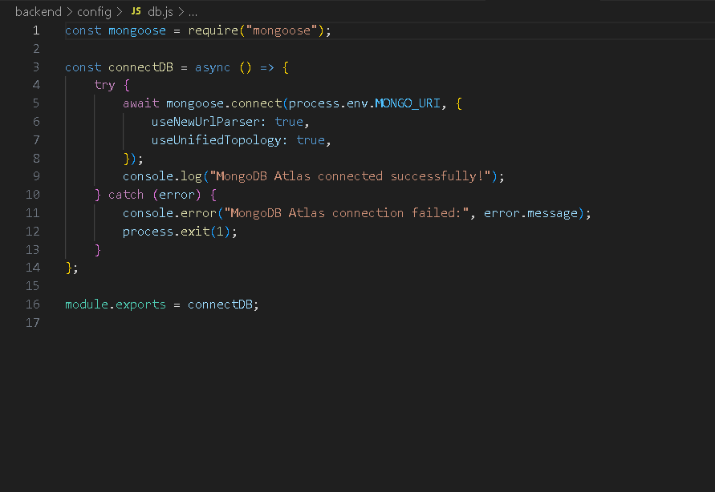

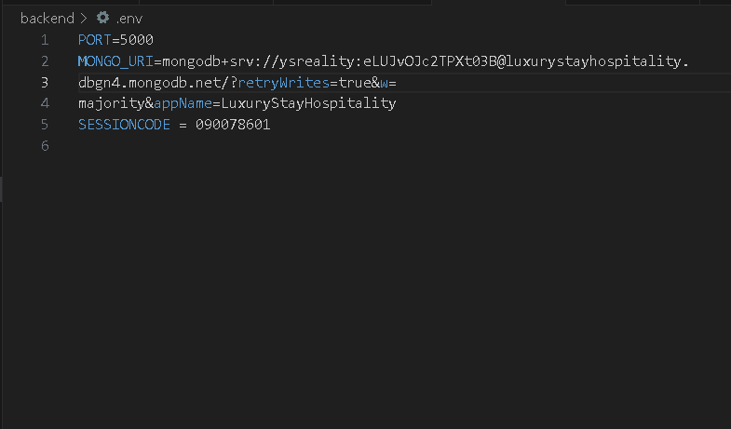

## APIs and CORS

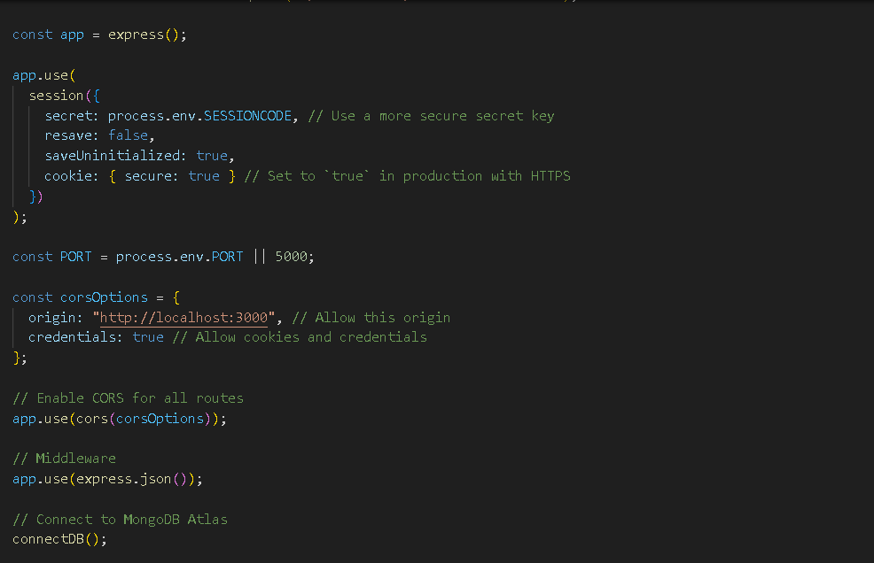

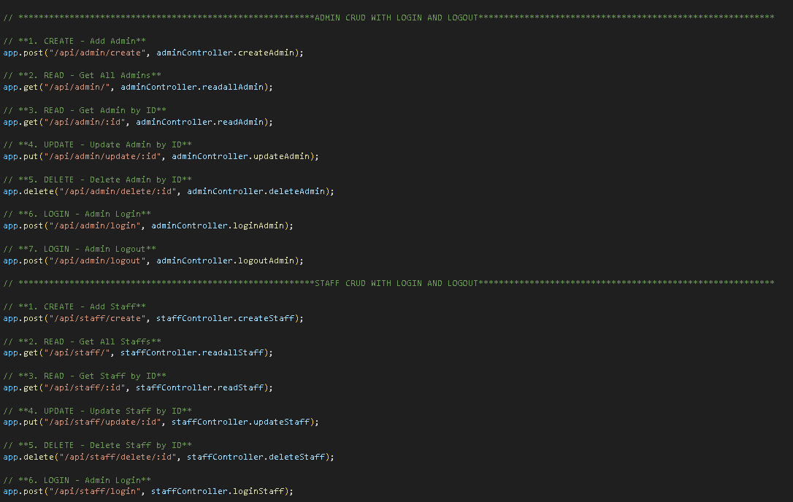

[**info@shaheencodecrafters.com**](mailto:info@shaheencodecrafters.com)

CONTACT US FOR ANY QUERIES